**MID-SEM SYLLABUS**

**Chemistry** -

* Electrochemistry
* Battery Technology
* Fuel Cells
* Metal Finishing
* Corrosion
* Chemical Fuels

**Maths** -

* First-order differential equations
* Higher-order differential equations
* Matrix
* Vector Spaces

**BET-**

* DC circuit analysis
* Magnetic circuit analysis

**BIO- CO1,CO2,CO3**

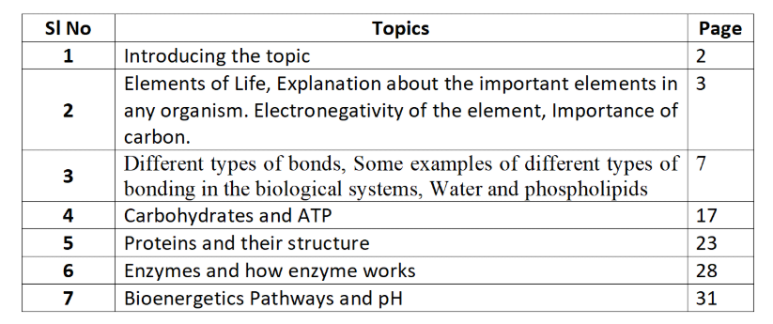

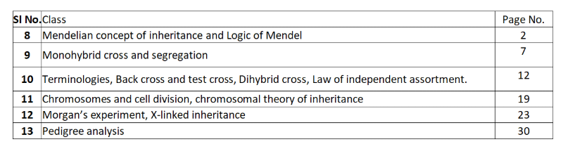

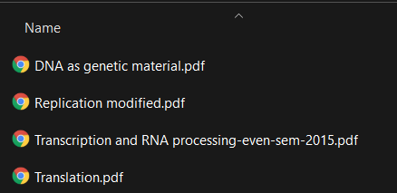

**EVS-**

Chapters-> **1-4**

Case Studies-> **1-4**

**PSUC-**

JITNA AAJ TAK HUA HAI :)

Suggestions on approaching these subjects

BET: Treat it like Math. All BET has is numericals and a very small amount of theory. Do the questions from the slides and use the lectures as reference. Learn to use the formulas and learn the circuit diagram conversions.

.

Chemistry and Biology are 80% theory so make proper notes in each topic.

For electrochem there are a few numericals and there will be one pedigree chart question in Bio. No other numerical based question.

EVS is supposedly a last minute subject. Learning the laws and dates and important concepts should help clear it. Last minute studying will not help though since I have already failed an exam. Refer to the slides

PSUC: He has referred a playlist that follows the syllabus. Make notes and do the codes on my own.

[9:39 pm, 23/12/2021] Ashrut: https://www.youtube.com/watch?v=si-KFFOW2gw&list=PLVlQHNRLflP8IGz6OXwlV_lgHgc72aXlh

I would really recommend doing the codes on the slides instead

And running them on your own

Math 1&2: Questions from BS Grewal

I have the textbook

|  |  |  |
| --- | --- | --- |
| **subject** | channel name |  |
| MATH | DR GAJENDRA PUROHIT | [Dr.Gajendra Purohit - YouTube](https://www.youtube.com/c/DrGajendraPurohitMathematics) |
| BIO | AMOEBA SISTERS(GENETICS) | [Amoeba Sisters - YouTube](https://www.youtube.com/c/AmoebaSisters) |
| PSUC | CODE WITH HARRY,NARESH I TECHNOLOGIES | <https://www.youtube.com/c/nesoacademy> |
| CHEMISTRY | ORGANIC CHEMISTRY TUTOR | [The Organic Chemistry Tutor - YouTube](https://www.youtube.com/c/TheOrganicChemistryTutor)  https://youtube.com/playlist?list=PLLf6O8XdGj00RTPIi8Gn0zXuaaZvcUDj4 |
| BET | NESO ACADEMY,TEKLES ACADEMY,MICHAEL VAN BIEZEN | [Neso Academy - YouTube https://www.youtube.com/c/MichelvanBiezen](https://www.youtube.com/c/nesoacademy) |